Acoustic Resonances in a Pipe

Nicholas Pun, 27872167

PHYS 229 L2B

Author Note

Lab equipment provided by UBC PHYS 229

Abstract

A model of the resonant modes of a given pipe can be found to be $f_{res}= {n*v_{sound}}/{2L}+b$ where $n$ is the $n^{th}$ resonance frequency, $v_{sound}$ is the speed of sound, $L$ is the pipe length, and $b$ is some vertical offset. From this model, we can see that the resonant modes of a pipe do not depend on the pipe diameter and only depends on the length. My experimentation produced the results $v_{sound}$ = 3.14e+02 +/- 3.428 m/s and $b$ = 1.072e+01 +/- 2.826e s^-1. This deviates from the theoretical model in that $v_{sound}$ at STP should be larger at 343 m/s and $b$ should be smaller at 0 s^-1. The theoretical model is $f_{res}= {n*v_{sound}}/{2L}$.

Keywords: resonance frequency, pipe length, pipe diameter.

# Introduction

I theorize that the model used to describe the acoustic resonance frequencies in a pipe is $f_{res}= {n*v_{sound}}/{2L}$. This is derived from two important pieces of information. First, is the fact that $f=v/λ$ where $f$ is the wave frequency, $v$ is the wave speed, and $λ$ is the wavelength. Second, the air within the pipe is being stretched and compressed to maintain the sound waves. This creates a pressure difference at different points in the pipe. Since the pressure outside of the pipe is at atmospheric pressure, the ends of the pipe must be anti-nodes for the air inside the pipe at these points to match the atmospheric pressure. This means that the length of the pipe is a scalar multiple of half the wavelength of the sound wave, or $L=n/2*λ$, or $λ=n/2*L$. Thus, by combining these two equations, we get $f= {n*v}/{2L}$. Since we are using sound waves, and since the second equation is a limits us to only resonance modes, we can more accurately derive the theoretical model to be $f_{res}= {n*v_{sound}}/{2L}$. Such a model would then suggest that the diameter of the pipe has no effect on the resonant modes.

### Experimental Methods

The following is a diagram of the apparatus used during my experiment.

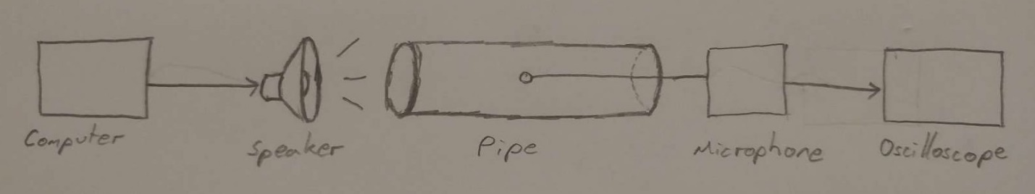

Figure : A computer provides a sinusoidal signal to the speaker, which creates sound waves into the pipe. The waves are detected by the microphone in the pipe and the output is displayed on an oscilloscope. The microphone is positioned approximately halfway into the pipe to minimize the ambient noise it detects.

To determine if diameter has an effect on the resonant frequencies, I examined the first resonant frequency of multiple pipes of varying diameters but equal lengths. At this point, I plot the data to conclude that the diameter does not affect resonance, and thus I can proceed with the rest of the experiment using pipes of any diameter knowing that the diameter will not affect the results. It is also important to note that during each test I needed to adjust the distance between the speaker and the pipe. I did this to change the strength of the signal such that the amplitude of the sound wave won't be larger than the limit of the microphone (~10V).

To determine if the length has an effect on the resonant frequencies, I record the first resonant frequencies of pipes with varying pipe lengths along with their lengths. However, in order to ensure that my data is unbiased, I test the pipes of equal diameters but different lengths, for varying sets of diameters. I then plot frequency versus pipe length to examine how the length affects the resonant frequency.

I use Python to determine the variables in my theoretical model. My program uses initial guesses for the variables, then finds the best fit curve to match the data and returns values for the variables that would result in that best fit curve.

### Results

After taking the set of data for the variation in diameter, I plotted the following. This graph corresponds to pipes of 0.5 m in length.

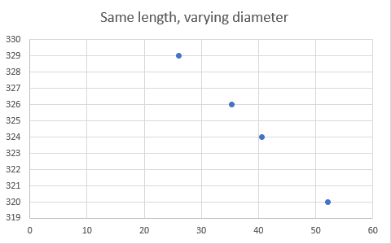

Plot : Frequency (Hz) vs. Pipe Diameter (mm)

At first glance it seems that there appears to be a linear trend where increasing pipe diameter linearly decreases the resonant frequency. However, even though there was a difference in the resonant frequencies of these pipes, the differences were small enough to be due to uncertainties. The range of resonant frequencies for this set of measurements was about 10 Hz, whereas the range of uncertainties was about 10-12 Hz. We learned that the distance between the speaker and the pipe caused the resonance to shift by +/- 8 Hz and that the oscilloscope's reading of the frequency of the input fluctuated by about 2 Hz. Therefore, the resonant frequency is not affected by the pipe’s diameter. On a frequency versus pipe length graph, these data points would all be grouped together at the same pipe length with a small vertical deviation in frequency. To improve accuracy of the experiment, I would need to take more data points within this group, although for this lab I could not as I was limited to a resource of only 4 different diameter pipes.

After taking the set of data for the variation in length, I plotted the following four graphs. Each graph corresponds to pipes of diameters 26.1 mm, 35.3 mm, 40.6 mm, and 52.1 mm respectively.

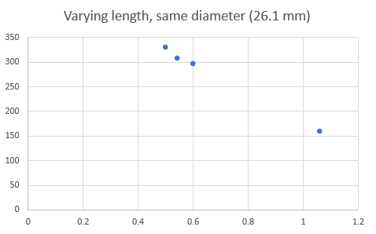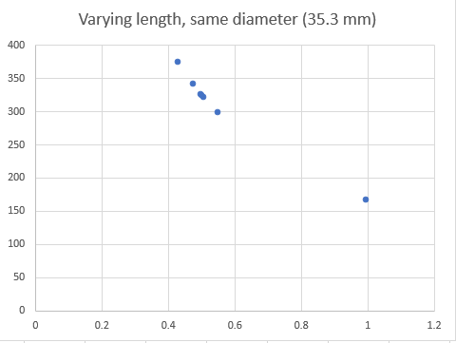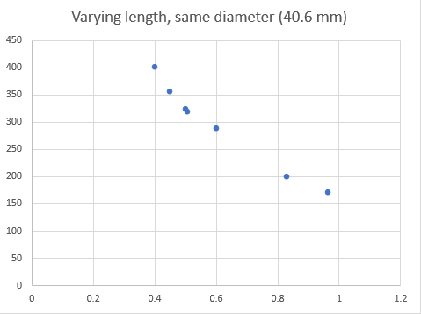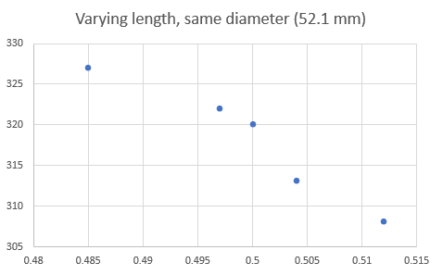

From each of these plots, it is clear that the pipe’s length does in fact effect the resonant frequency. Furthermore, each group does not follow a linear trend.

Since we already determined that the diameter does not affect the resonant frequency, we can use all the data points of the last 4 groups together. This is what the following graph represents.

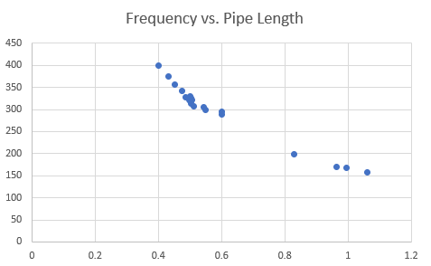

On this graph, all the data points are plotted and shows a clear inverse relationship. At some points there is some deviation from what would be the line of best fit, however these can be accounted for by uncertainties.

While creating the line of best fit, I took inspiration from the best fit codes from Phys 219. I started with my base model of what I believed the relationship to be (1/x) and multiplied that by a constant m. I also add a vertical offset b for the y_offset. I then run the code while varying the constants in order to achieve a good fit. To determine the goodness of my fit I plot the residuals and uncertainties to see if my resulting Chi^2/(degree of freedom) is low enough (less than 1).

I already have an idea that the first resonant frequency should be where the wavelength of the sound is equal to 2 times the length of the pipe. This will be the first case where the ends of the pipe contain nodes of the standing sound wave. Knowing this, I start with the initial guess that the constant is around v_sound/2 = ~171 and that the y_offset = 0, as that would make the frequency = v_sound/(2x) = v_sound/λ. Then the general equation for all resonant frequencies is then n*v_sound/(2x) for all integers n>0. The work is shown in the picture below.

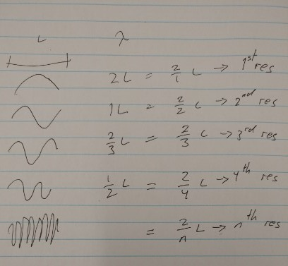

The resulting fit appears in the first image below. Its residual information is graphed in the second image below.

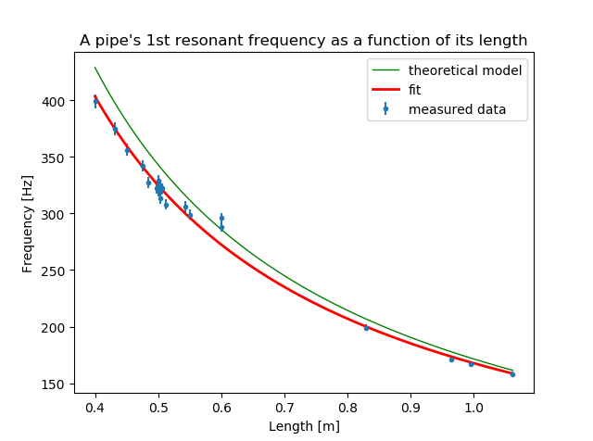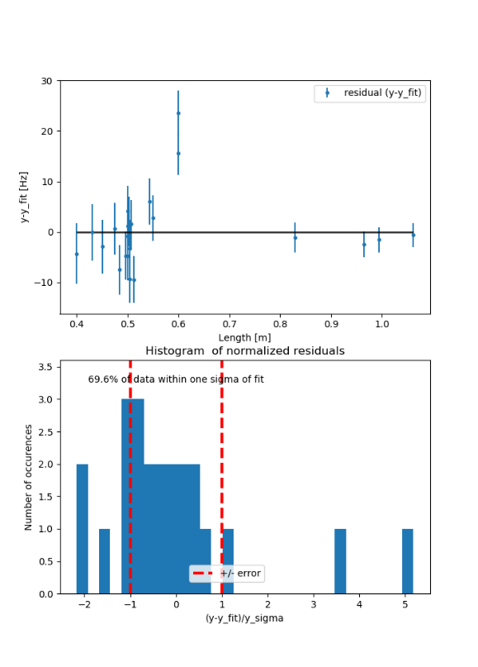

*The figure above is a graph of a pipe’s natural resonant frequency as a function of its length and the data’s residual information that describes the accuracy of the fit. The goal of this experiment was to determine how a pipe’s diameter and length affects the resonant frequenc, and so the data points are natrual frequency measurements of a variety of different length and diameter pipes. The model of this fit was derived to be $f_{n^{th}res}\left(L\right)=\frac{nv_{sound}}{2L}+b$ where n is an integer greater than 0, vsound is the speed of sound, L is the length of the pipe, and b is some vertical offset (n=1, vsound = 3.14*102 +/- 3.428 m/s, b = 1.072*101 +/- 2.826 in our experiment). From the data and model, we can see that the length of the pipe is inversely proportional to the resonant frequency and that the diameter of the pipe has no affect, which is why we are able to graph pipes of varying diameters without worrying that the diameter variable will skew the fit. The residual information shows that I have produced an accurate fit with my model as 69.9% of data within 1 standard deviation resulted in a low calculated Chi2/(degree of freedom) of 2.83.*

initial guesses = (343/2, 0)

Goodness of fit - chi square measure:

Chi2 = 59.51850706031553, Chi2/dof = 2.834214621919787

Fit parameters:

m = 1.570e+02 +/- 1.714e+00

y_offset = 1.072e+01 +/- 2.826e+00

Residual information:

69.6% of data points agree with fit

This fit is good as the Chi^2/dof is reasonably low. The experimental constant m was 1.570e+02 +/- 1.714e+00 [m/s] and the experimental offset y_offset was 1.072e+01 +/- 2.826e+00 [s^-1]. The experimental constant m was still smaller than the calculated constant m, and this still aligns with research I did online that suggested that the measured resonant frequency will almost always be smaller than the calculated resonant frequency. The experimental y_offset was still larger than the calculated y_offset, and this can no longer be accounted for by the uncertainty.

From the fit, we can deduce that the speed of sound in our experiment was 3.14e+02 +/- 3.428e+00 [m/s]. This is lower than the speed of sound that we know (343 [m/s]). Some possible (but not probable) reason for this is that temperature was colder than STP, or that the atmospheric pressure was larger than at STP. We know that the medium can affect the speed of sound. For example, the speed of sound in water is 1498 [m/s], 4.8 times faster than in air.

Conclusively, this experiment led us to derive the equation f_res = n*v_sound/(2L)

### Conclusion

The results of the experiment prove that the model for acoustic resonance in a pipe does not include the pipe’s diameter and is only affected by the speed of sound and the pipe’s length. The model is $f_{res}= {n*v_{sound}}/{2L}+b$. There are some uncertainties, which is why the constant $b$ must be included. However, if I were to test more extreme ratios of pipe length and diameters, my error in the experimental result in the speed of sound and the offset would be reduced. My model with the errors included is $f_{res}= {n*314}/{2L}+10.7$.